Homework 3
Climate Change Ecology, Spring 2013
Due Thursday, February 28, 2013

Your name: ___________________________________________________

Please answer the following questions in a different font (like this) to help me find your answers. Turn in a print out of your homework. You may work in a group, but your answers and your words must be your own.

List all sources of information. Do not plagiarize.

See Links section of the course web site for reports and articles.

I. Location comparisons

Remind me of your hometown ________________ and Location #2 _______________.

1. (4 points) Using Figures 2.9 and 2.10 of the Draft National Climate Assessment, what has been the past change and what are the projected future changes (both scenarios) in the frost-free season in your hometown?

2. (5 points) From the maps in Figures 6.2-6.6 in Hannah, describe changes in forest that have occurred at your two locations during the last 90 million years. Relate changes to global temperature at the time of any changes. Are tropical forests currently at either of your locations?

3. (4 points) Using Figure 4.3 from Chapter 4 of the IPCC AR4, Working Group II report (Impacts, Adaptation, and Vulnerability), describe changes in habitat at your two locations (roughly) for both sets of model results. If your location(s) don’t have any changes, describe the nearest change (where is that?).

II. Species range shifts

4. (3 points) What are the three ways that organisms can respond to climate change? Which is associated with range shifts?

5. (2 points) Why have species range shifts been better documented in the temperate and polar latitudes than in the tropics?

6. (3 points) What are the three types of indirect effects of climate change on species range shifts (contraction or expansion)? Give an example of each.

7. (3 points) List the attributes of each of the following that lead to more likely extinctions from climate change, and describe why:
a. population size
b. sensitivity to climate change
c. habitat availability (including potential future habitat)

8. (4 points) Climate change has forced species ranges shifts in the (distant) past. What are two differences about climate change today that may limit a species’ ability to adapt? Why?

9. (8 points) Describe the important messages in each of the four panels of the below figure from Post et al., Science, 2009.

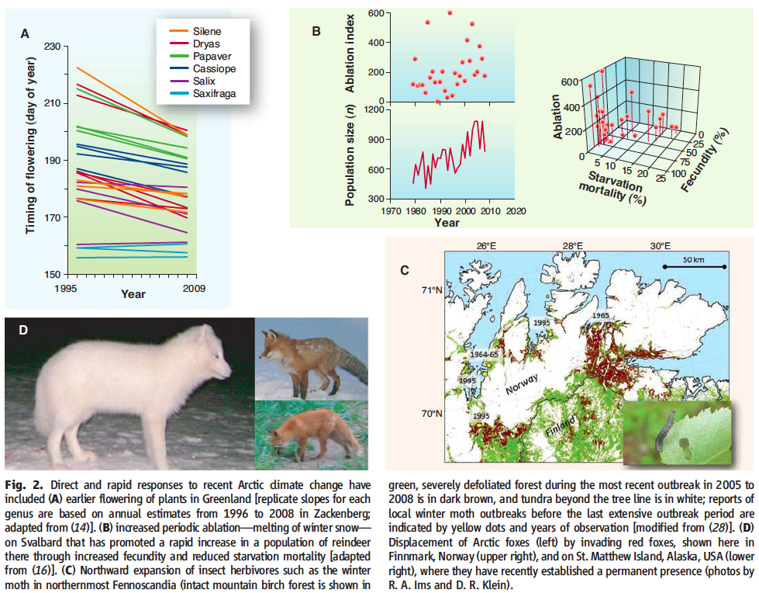

III. Phenology

10. (3 points) Why are phenological studies some of the best for establishing the impacts of climate change on biology?

11. (10 points) Download “moscow_tmin_tmax_2012.csv” from the course web site under Homework. This CSV file gives the date, maximum temperature, and minimum temperature for the Moscow weather station in 2012. Calculate the growing degree day amount above a baseline of 10ºC for each day, then the cumulative growing degree days (since January 1) for each day in the entire time series. When did lilacs bloom (which bloom after 100 GDD)? If you assume a climate change scenario of 2ºC in 2100 (applied evenly throughout the year), when will lilacs bloom then? What is the time difference?

12. (6 points) List and explain three reasons why climate change may lead to phenological timing mismatches between species.

IV. Ecosystems and habitats

13. (6 points) List and describe one example of each of the following as well as one example of how recent or projected future climate change will affect each:

a. Ecosystem structure

b. Ecosystem function

c. Ecosystem service

14. (6 points) Describe in a paragraph two examples of changes in the physical climate system that have affected ecosystems and habitats.

V. Paleoecology

15. (5 points) Characterize (describe) the temperature changes during the a) last 100s of millions of years as well as during the b) last 2 million years. (Do not use Figure 9.2 in Hannah as it does not represent global surface temperature.) What were the temperatures? What was the magnitude of temperature changes, and over what time period did these changes occur (speed of warming/cooling)?

16. Read the discussion of the Paleocene-Eocene Thermal Maximum in Hansen’s paper (supplemental material) assigned earlier on dangerous anthropogenic interference of the climate system, the Wikipedia page on the PETM, and the review by McInerney and Wing.

a. (1 point) What was the global mean surface temperature (use Figure 9.1 in Hannah)?

b. (1 point) What was the magnitude of the warming, and over what time frame did it occur?

c. (1 point) What feedbacks amplified this warming?

d. (2 points) Why is this period an analog for current and projected future climate change?

e. (1 point) What was different about the mean temperature during this period compared with today’s climate?

f. (2 points) What is the difference between the warming (change in temperature) then and what is happening today?

g. (2 points) What were the implications for life (Wikipedia page more correct about extinctions than Hansen)?

