Homework 4
Climate Change Ecology, Spring 2013
Due Thursday, April 4, 2013

Your name: ___________________________________________________

Please answer the following questions in a different font (like this) to help me find your answers. Turn in a print out of your homework. You may work in a group, but your answers and your words must be your own.

List all sources of information unless obvious from text of question. Do not plagiarize.

I. Responses of agriculture to climate change

Read the chapter on agriculture (pp 71-78) of the following report (links also available on course web site; you can also read the web page at http://globalchange.gov/publications/reports/scientific-assessments/us-impacts/climate-change-impacts-by-sector/agriculture):

USGCRP (2009). Global Climate Change Impacts in the United States . Karl, T.R., J.M. Melillo, and T.C. Peterson (eds.). United States Global Change Research Program. Cambridge University Press, New York, NY, USA

1. (6 points) Explain the three influences by which climate change will affect crop production.

2. (4 points) Explain how increasing atmospheric CO2 concentrations impacts US livestock production (one positive effect and one negative effect).

3. (4 points) What is one adaptation strategy to reduce climate change effects on crop production and one adaptation strategy for livestock production?

4. (6 points) The below figure, taken from Chapter 5 of the 2007 IPCC report from Working Group II (Impacts, Adaptation, and Vulnerability), shows the percent change in yield for a given temperature increase for three different crops and two different geographic regions. What are two main messages of this figure?

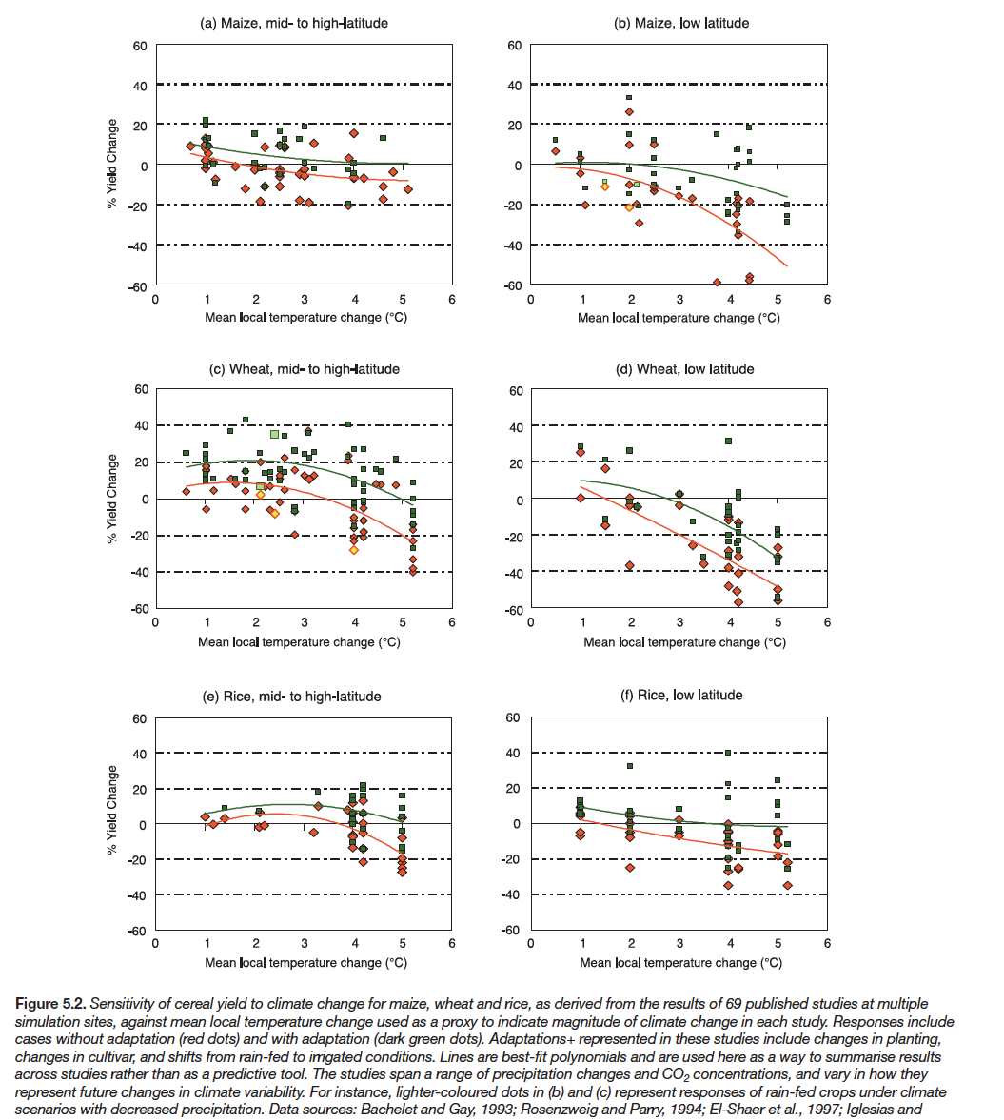

5. (4 points) What surprised you most after reading about this topic?

II. Joint attribution

6. (4 points) What two links have to be made to attribute anthropogenic climate change to biological responses? A useful reference is Chapter 1 of the 2007 IPCC report from Working Group II (Impacts, Adaptation, and Vulnerability) (see Links on course web site).

7. (4 points) Explain how anthropogenic climate change was responsible for pinyon pine mortality in the Southwest. Describe the two links referred to above. (See also Breshears et al., PNAS, 2005, http://www.pnas.org/content/102/42/15144 for more information.)

8. (8 points) List two other biological responses that you think clearly demonstrate the role of anthropogenic climate change on biological responses. Describe the responses and attribution.

III. Methods for predicting future impacts

9. (4 points) What is one strength and one weakness of field experiments of climate change impacts compared with laboratory experiments?

10. (4 points) What is one strength and one weakness of species distribution modeling?

IV. Communicating climate change

11. (15 points) What are your three favorite storylines that illustrate climate change and its impacts (which do you feel are most effective)? Include at least one from the western US; you may consider biological responses (as in Question 8 above) or physical climate responses. Describe the storylines in detail in one paragraph each (complete sentences, please).

